Similarity Analysis of CVEs Using Data Mining Techniques

1. Introduction
In this assignment, data mining techniques were applied to identify similar items within a cybersecurity dataset. The objective was to analyze and compare vulnerabilities (CVEs) using different similarity algorithms, in order to understand how various features influence similarity detection.
The selected items for analysis were Common Vulnerabilities and Exposures (CVEs), as they represent real-world security issues and include both textual and structured data.

2. Data Description
The dataset used in this analysis was collected from the National Vulnerability Database (NVD) and includes approximately 20,000 recent CVE records.
Each record contains the following relevant fields:
- cve_id
- description
- cwe (Common Weakness Enumeration)
- severity_score (CVSS score)
This dataset is well suited for similarity analysis because it includes:
- textual data (description)
- categorical data (CWE)
- numerical data (severity score)

3. Methodology

3.1 Problem Definition
The goal of this analysis was to identify similar vulnerabilities using different similarity algorithms and compare their effectiveness.
Each CVE was treated as an individual item, and similarity was computed between CVEs based on selected features.

3.2 Feature Selection
The following features were selected:
- Textual feature:description
- Categorical feature:cwe
- Numerical feature:severity_score

3.3 Data Preparation
The following preprocessing steps were performed:
- Missing values in description were replaced with empty strings
- Missing values in cwe were replaced with "UNKNOWN_CWE"
- Missing values in severity_score were handled where necessary
- Text was normalized using lowercasing and tokenization for Jaccard similarity

3.4 Similarity Algorithms
Two different similarity approaches were applied:
Cosine Similarity with TF-IDF:
- Used for textual similarity
- CVE descriptions were converted into TF-IDF vectors
- Cosine similarity was computed between vectors

Jaccard Similarity:
- Used for set-based similarity
- CVE descriptions were converted into sets of words
- In the categorical version, sets also included cwe and severity_score

4. Results

4.1 Cosine Similarity Without Category
Similarity was calculated based only on the textual description of each CVE.
Top 5 similar CVEs:
- CVE ID: CVE-2024-14028
Similarity Score: 0.53
- CVE ID: CVE-2025-50191
Similarity Score: 0.3638
- CVE ID: CVE-2025-65017
Similarity Score: 0.3615
- CVE ID: CVE-2025-52476
Similarity Score: 0.3522
- CVE ID: CVE-2025-50199
Similarity Score: 0.3511
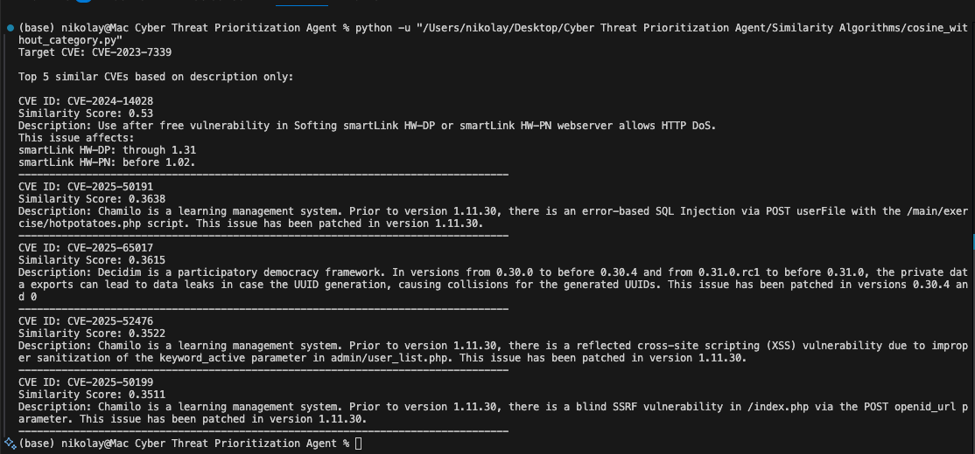
The results indicate that cosine similarity successfully identifies CVEs with similar textual patterns, including repeated structures, product names, and vulnerability descriptions.

4.2 Cosine Similarity With Category
Similarity was calculated using a combination of description, cwe, and severity_score.
Top 5 similar CVEs:
- CVE ID: CVE-2024-14028
Similarity Score: 0.5244
CWE: CWE-416
Severity Score: 6.5
- CVE ID: CVE-2025-50191
Similarity Score: 0.3536
CWE: CWE-89
Severity Score: 7.2
- CVE ID: CVE-2025-52476
Similarity Score: 0.3524
CWE: CWE-79
Severity Score: 6.1
- CVE ID: CVE-2025-65017
Similarity Score: 0.35
CWE: CWE-200, CWE-703
Severity Score: 6.5
- CVE ID: CVE-2025-50190
Similarity Score: 0.3389
CWE: CWE-89
Severity Score: 9.8
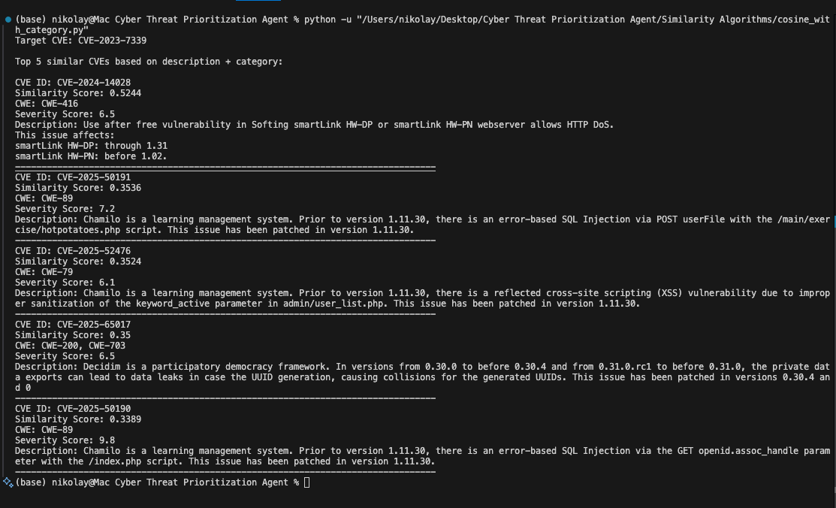
The results show that adding categorical features slightly changed the similarity scores but did not significantly change the ranking. This indicates that textual similarity remained the dominant factor.

4.3 Jaccard Similarity Without Category
Similarity was calculated using sets of words extracted from the CVE descriptions.
Top 5 similar CVEs:
- CVE ID: CVE-2025-10685
Similarity Score: 0.625
- CVE ID: CVE-2025-13406
Similarity Score: 0.3704
- CVE ID: CVE-2026-24497
Similarity Score: 0.3571
- CVE ID: CVE-2025-10504
Similarity Score: 0.3333
- CVE ID: CVE-2025-10461
Similarity Score: 0.303
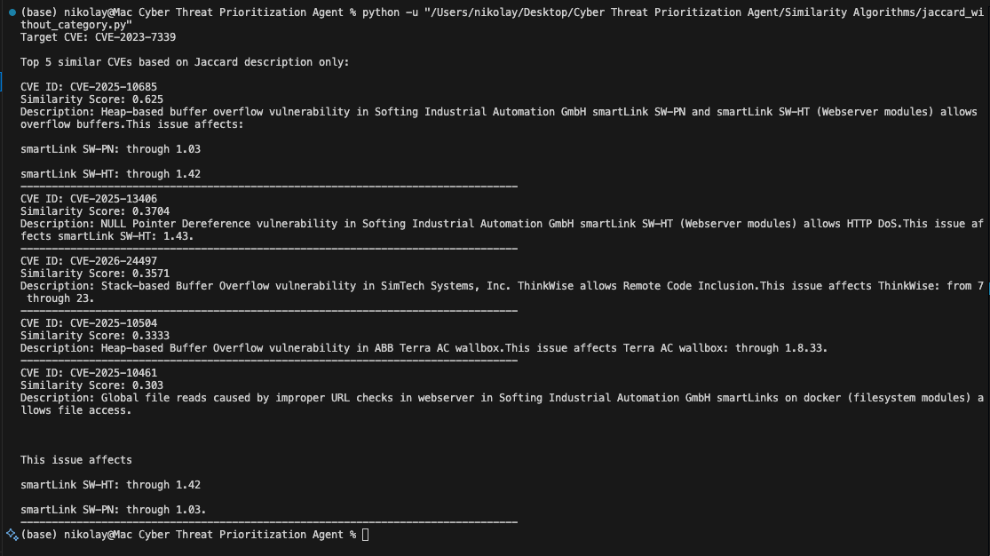
The results demonstrate that Jaccard similarity identifies CVEs based on shared words, particularly focusing on overlapping terminology such as product names and vulnerability types.

4.4 Jaccard Similarity With Category
Similarity was calculated using combined sets including description words, cwe, and severity_score.
Top 5 similar CVEs:
- CVE ID: CVE-2025-10685
Similarity Score: 0.5357
CWE: CWE-122
- CVE ID: CVE-2026-24497
Similarity Score: 0.3438
CWE: CWE-121, CWE-787
Severity Score: 9.8
- CVE ID: CVE-2025-13406
Similarity Score: 0.3226
CWE: CWE-476
- CVE ID: CVE-2024-14028
Similarity Score: 0.3
CWE: CWE-416
Severity Score: 6.5
- CVE ID: CVE-2025-10504
Similarity Score: 0.2857
CWE: CWE-122
Severity Score: 6.1
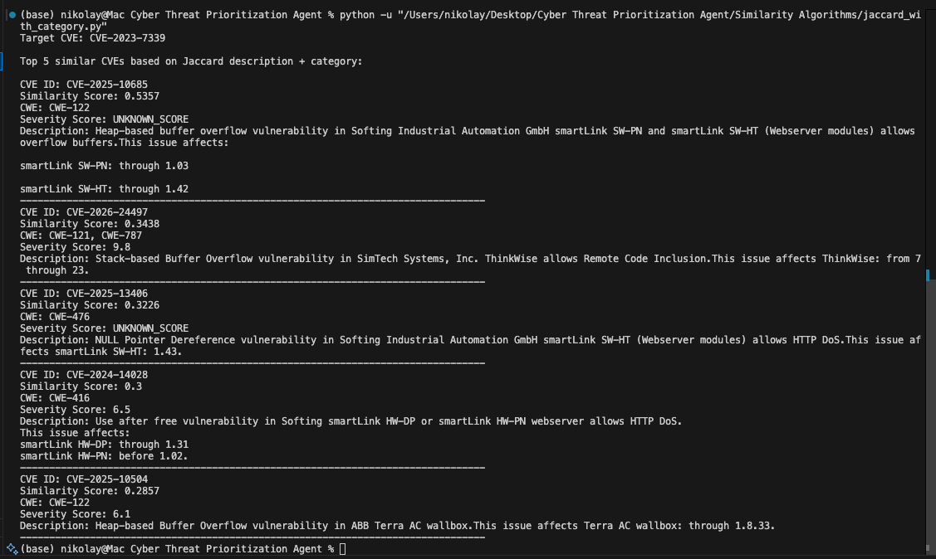
The results show that adding categorical features significantly influenced the similarity calculation, emphasizing vulnerabilities with similar types and classifications.

5. Discussion
The results highlight that different similarity algorithms capture different aspects of similarity.
Cosine similarity focuses on semantic relationships between CVEs, while Jaccard similarity emphasizes shared features and exact overlaps.
Additionally, categorical features had a stronger impact on Jaccard similarity compared to cosine similarity.

6. Conclusion
In this assignment, two similarity algorithms were applied to identify similar vulnerabilities in a large cybersecurity dataset.
The analysis demonstrated that:
- Cosine similarity is effective for capturing textual similarity
- Jaccard similarity is effective for identifying shared features
- Adding categorical features improves similarity detection, especially for set-based methods

